
Taller semana 2


8 de febrero de 2026
juan sebastian garavito mejia

- Ordenar las funciones de menor a mayor.
- n
- $n-n^{3}+7n^{5}$
- $n^{2}+log⁡(n)$
- $n^{3}$
- $2^{n}$
- $\log{(n)}$
- $n^{2}$
- $(\log{(n))^{2}}$
- $n\log\left(n\right)$
- $\sqrt{n}$
- $2^{n-1}$
- $n!$
- $\ln{(n)}$
- $e^{n}$
- $log⁡(\log\left(n\right))$
- $n^{1+ε}, 0<ε<1$
Funciones organizadas:
- $log⁡(\log\left(n\right))$
- $\log{(n)}$
- $(\log{(n))^{2}}$
- $\ln{(n)}$
- $\sqrt{n}$
- n
- $n\log\left(n\right)$
- $n^{1+ε}, 0<ε<1$
- $n^{2}$
- $n^{2}+log⁡(n)$
- $2^{n-1}$
- $2^{n}$
- $n^{3}$
- $n!$
- $e^{n}$
- $n-n^{3}+7n^{5}$
- Para las siguientes funciones, determinar el resultado como una función de n y representar el peor caso de ejecución con notación Big Oh:

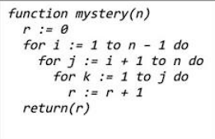
function mystery(n) | cost | Time
r := 0 | $$c_{1}$$ | $$1$$
for i := 1 to n-1 do | $$c_{2}$$ | $$(n-1)$$
for j := i + 1 to n do | $$c_{3}$$ | $$n(\sum_{j=i+1}^{n}{t_{j}})$$
for k := 1 to j do | $$c_{4}$$ | $$n(\sum_{j=i+1}^{n}{t_{j}}-1)(\sum_{k=1}^{j}{t_{k}})$$
r := r + 1 | $$c_{5}$$ | $$n(\sum_{j=i+1}^{n}{t_{j}}-1)(\sum_{k=1}^{j}{t_{k}}-1)$$
return(r) | $$c_{6}$$ | $$1$$

Peor caso:
$$T\left(n\right)={O(n}^{3})$$

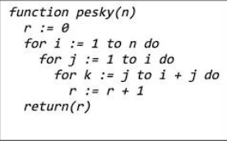

function mystery(n) | cost | Time
r := 0 | $$c_{1}$$ | $$1$$
for i := 1 to n do | $$c_{2}$$ | $$n$$
for j := 1 to i do | $$c_{3}$$ | $$(n-1)\sum_{j=1}^{i}{t_{j}}$$
for k := j to i + j do | $$c_{4}$$ | $$(n-1)( \sum_{j=1}^{i}{t_{j}}-1)(\sum_{k=j}^{i+j}{t_{k}})$$
r := r + 1 | $$c_{5}$$ | $$(n-1)( \sum_{j=1}^{i}{t_{j}}-1)(\sum_{k=j}^{i+j}{t_{k}}-1)$$
return(r) | $$c_{6}$$ | $$1$$

Peor caso:
$$T\left(n\right)={O(n}^{3})$$

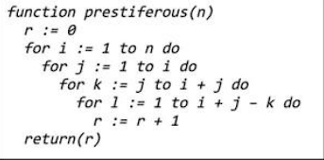

function mystery(n) | cost | Time
r := 0 | $$c_{1}$$ | $$1$$
for i := 1 to n do | $$c_{2}$$ | $$n$$
for j := 1 to i do | $$c_{3}$$ | $$(n-1)( \sum_{j=1}^{i}{t_{j}})$$
for k := j to i + j do | $$c_{4}$$ | $$(n-1)( \sum_{j=1}^{i}{t_{j}}-1)( \sum_{k=j}^{i+j}{t_{k}})$$
for l := 1 to i + j – k do | $$c_{5}$$ | $$(n-1)( \sum_{j=1}^{i}{t_{j}}-1)( \sum_{k=j}^{i+j}{t_{k}}-1)(\sum_{l=1}^{i+j-k}{t_{l}})$$
r := r + 1 | $$c_{6}$$ | $$(n-1)( \sum_{j=1}^{i}{t_{j}}-1)( \sum_{k=j}^{i+j}{t_{k}}-1)(\sum_{l=1}^{i+j-k}{t_{l}}-1)$$
return(r) | $$c_{7}$$ | $$1$$

Peor caso:
$$T\left(n\right)={O(n}^{4})$$
- Implementar el algoritmo de insertion sort para ordenar de forma descendente en vez de ascendente.

Original:
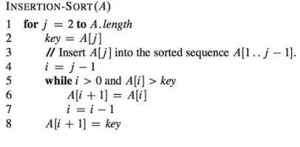

De manera descendente:
